Papenweg 101, 6212 CE Maastricht Tel. 06 434 78 030

[loekbongaarts.nl@gmail.com](mailto:loekbongaarts.nl@gmail.com) www.linkedin.com/in/loekbongaarts

Website <www.loekzoekt.nl>

LSR III Logistics Mercedes Benz

Loek Bongaarts

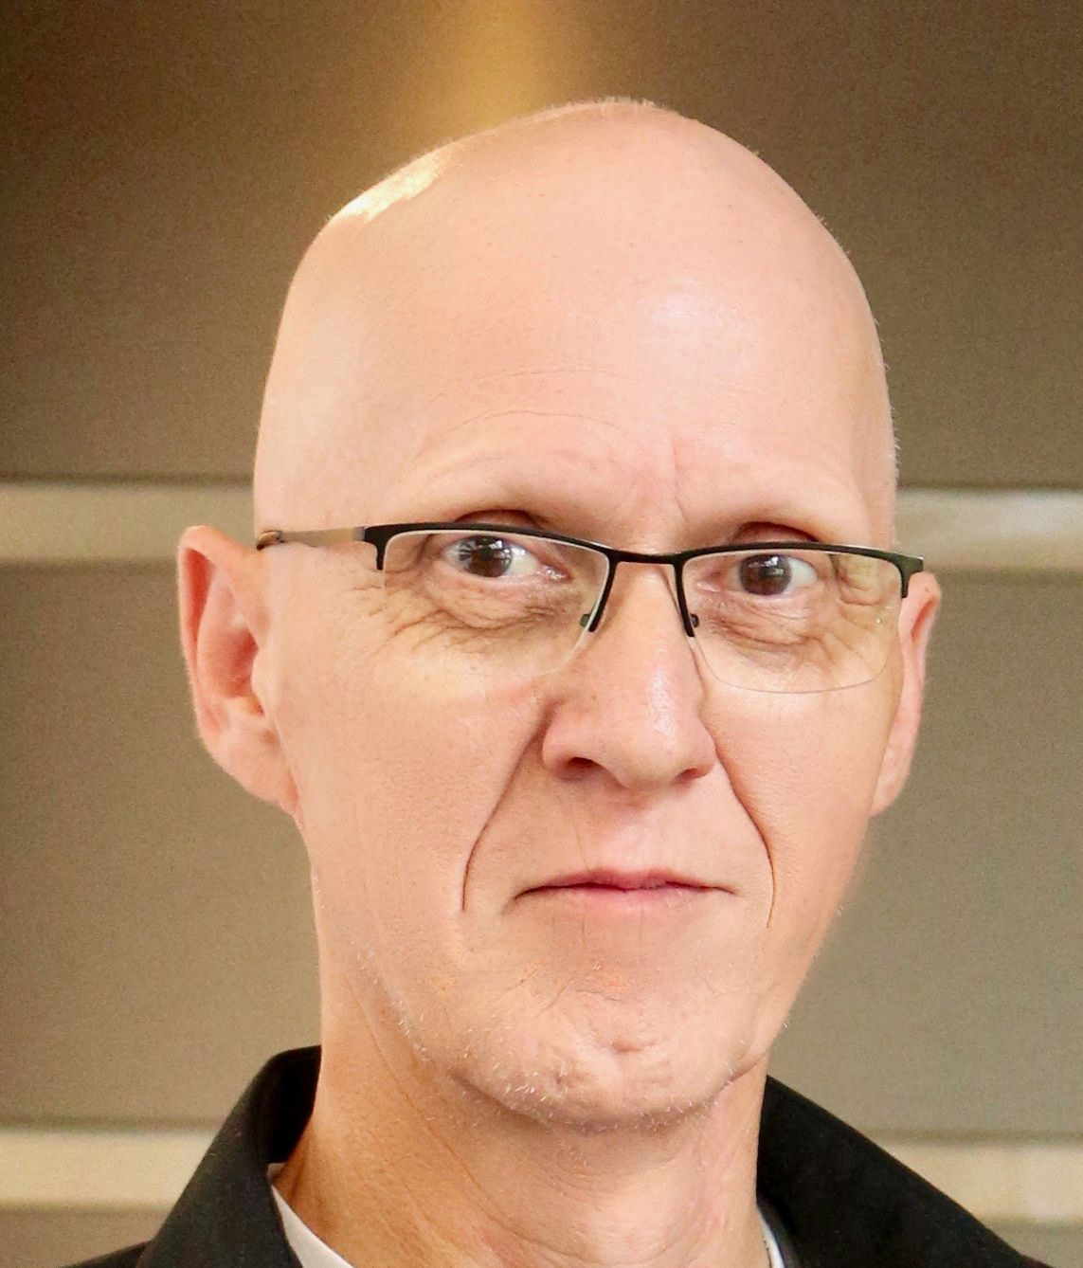

# About me :

Over 15 years of experience in Logistics, from warehousing, customer service to billing. Team lead, coach, communicator, translator. I am now looking for an empowering job in which I can use my communication, coaching, creativity and language skills.

Former music teacher and semiprofessional musician (15 years)

# Skills

MS Office

S A P / JD Edwards

### 

Adobe PS AE PR

### 

# Languages

Dutch

### 

English

German

### 

French

# Experience

## LSR III Logistics (deputy manager)

*Mercedes Benz CAC Maastricht | June 2017 – May 2022*

Tasks and responsibilities:

* Coaching a team of 6 customer service agents.
* Solving logistic issues for Mercedes Benz dealerships in the Benelux and ensuring speedy delivery of critical car parts.
* Helping dealerships with logistic support for car parts coming from  
  locations worldwide.
* Keeping work instructions up to date.
* Communication and translation for dealers to main German and French warehouses.

## Translator/ Patient Liaison Officer

*US Clinic Nato Airbase Geilenkirchen | June 2015 – May 2017*

Tasks and responsibilities:

* Translating for American Airforce staff when visiting hospitals or doctors (translation German – English and visa-versa).
* Translation of medical files from hospitals and doctors (German - English).

## Unemployment Benefits Assessor

*UWV Heerlen | January 2013 – December 2014*

Tasks and responsibilities:

* Assessing demands for unemployment benefits.
* Determination of time period and amount per case.
* Contacting customers, Tax administration and lawyers.

## Logistic coordinator

*Hydranautics Maastricht | July 2011 - September 2011 (project)*

Tasks and responsibilities:

* Setup of a new logistic network.
* Negotiating transport tariffs
* Coordination of container transport from the US and Japan.

## Team lead Reversals

*DHL EFSS Maastricht | February 2007 – May 2011*

Tasks and resonsibilities:

* Coaching of 15 billing agents.
* Mid/ end year reviews of agents.
* Reporting of weekly monthly data to higher management.
* Training and coaching of new agents using self-developed training course.
* Handling escalations from the German and French markets.
* Evaluated billing procedures and guide lines.

## Billing agent

*KLG Europe Venlo | February 2004 – January 2007*

Tasks and responsibilities:

* Billing of air- sea- and landfreight.
* Keeping billing tariffs and master file data up-to –date.
* Calculating adhoc tariffs.
* Reviewing of tariffs as offered by sales department..

# Competencies

Patient Eager to learn

Communication Creative

Reliable

# Other activities

Organist St. Pieter Maastricht

Gregorian music

Helpdesk computer issues for ttthe elderly in our neighborhood.

Hobbies

Organ Dogs Adobe AE Cooking Genealogy Website

# Other

I’m keeping a website up to date about my family tree, our dogs and the digital virtual organ I built myself. Contains my family tree, photo, video and audio material.  
[www.loekzoekt.nl](http://www.loekzoekt.nl) (Dutch)



## Billing agent

*Ziegler Venlo | August 2000 – January 2004*

Tasks and responsibilities:

* + Billing import/ export Switzerland and Italy.
  + Training/ coaching colleagues in computer skills.
  + Daily contact with Swiss colleagues.
  + Started here as warehouse keeper.

## Teacher accordion, piano and keyboard

*Clara Schumannmusikschule Düsseldorf | August 1989 – June 2000*

Tasks and responsibilities:

* Teaching children and adult show to play the above mentioned instruments.
* Teaching children and adults musical theory (reading scores, musical theory needed for composing, improvising.
* Organizing play evenings so students could show their progress and proving school management my teachings were showing results.

# Education

## Conservatorium

*Conservatorium Maastricht | 1982 – 1987*

Education for DM (Bachelor of Art) organ, accordion and keyboard.

## HEAO Communication Sciences

*HEAO Eindhoven | 1979 - 1981*

Was a pilot study back then, only 1 in 30 was admitted.

## Havo

*St. Thomascollege Venlo | 1973 - 1979*

# Courses & Trainings

## Dutch labor law

*DHL 2007*

Mandatory course for team leads, very useful info when needed.

## Handling requests for unemployment benefits (WW)

*UWV Heerlen January 2013 – July 2013*

Mandatory course obviously for starting job at UWV.

## Conflict handling

*DHL 2008*

Given the multi-cultural work environment at DHL this course was mandatory.

## Emotional awareness

*Mercedes Benz June 2018*

Handling of stressful situations which appear in a customer service department.